**Task 1: Create an Elastic Beanstalk Environment with PHP Runtime**

1. **Open AWS Elastic Beanstalk Console**:
   * Sign in to the AWS Management Console.
   * Open the **Elastic Beanstalk** service.
2. **Create a New Environment**:
   * In the Elastic Beanstalk Console, click **Create a new environment**.
   * Choose **Web server environment** and click **Select**.
3. **Configure the Environment**:
   * Enter a name for your environment (e.g., PHP-Environment).
   * In the **Platform** section, select **PHP**.
   * Choose a platform branch and version. The default will typically be the latest stable PHP version.
4. **Set Up Application Code (Optional at This Stage)**:
   * You can either upload your application code here or do it later. If you want to proceed without uploading the code at this point, click **Skip** on the code upload section.
5. **Review and Launch**:
   * Review your configuration and click **Create environment**.
   * AWS will provision the environment with PHP runtime. This process might take a few minutes.

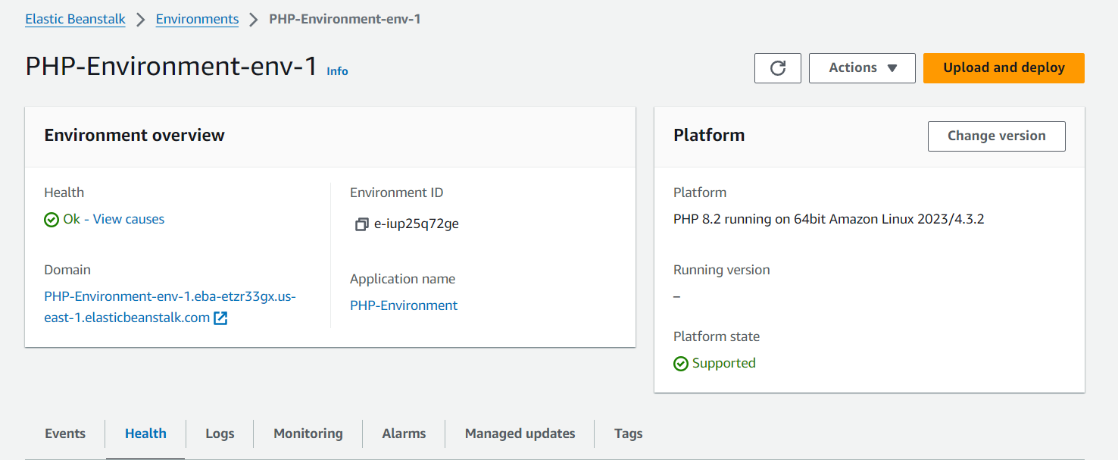

**Task 2: Upload a Simple PHP File to the Environment**

1. **Create a Simple PHP File**:
   * On your local machine, create a PHP file (e.g., index.php) with the following content:

<?php

echo "Hello from Elastic Beanstalk!";

?>

1. **Upload the PHP File to Elastic Beanstalk**:
   * After your environment is created, return to the **Elastic Beanstalk Console**.
   * Select your environment (PHP-Environment).
   * Click on **Upload and deploy**.
   * Choose your simple PHP file or a zipped version of your PHP project.
   * Click **Deploy**.
2. **Access the Application**:
   * Once the deployment is complete, Elastic Beanstalk will provide a URL for your application (e.g., http://php-environment.us-east-1.elasticbeanstalk.com).
   * Open the URL in a web browser, and you should see the output: Hello from Beanstalk!